Project Development Phase
Performance Test

Date | 03 October 2026
Team ID | SWTID-2026-6867
Project Name | Streamlining IT Procurement: Automating Standard Laptop Orders with Flow Designer
Maximum Marks | 5 Marks

Model Performance Testing:
Project team shall fill the following information in model performance testing template.
S.No. | Parameter | Screenshot / Values
 | Data Rendered | ServiceNow procurement request records and laptop order data are rendered successfully.
 | Data Preprocessing | Laptop request data is validated and prepared before processing through Flow Designer.
3. | Utilization of Filters | Filters are used to view laptop procurement requests based on request status, approval status, and fulfillment status.
4. | Calculation fields Used | Calculation fields are used to track procurement request status, processing information, and request-related values.
5. | Dashboard design | 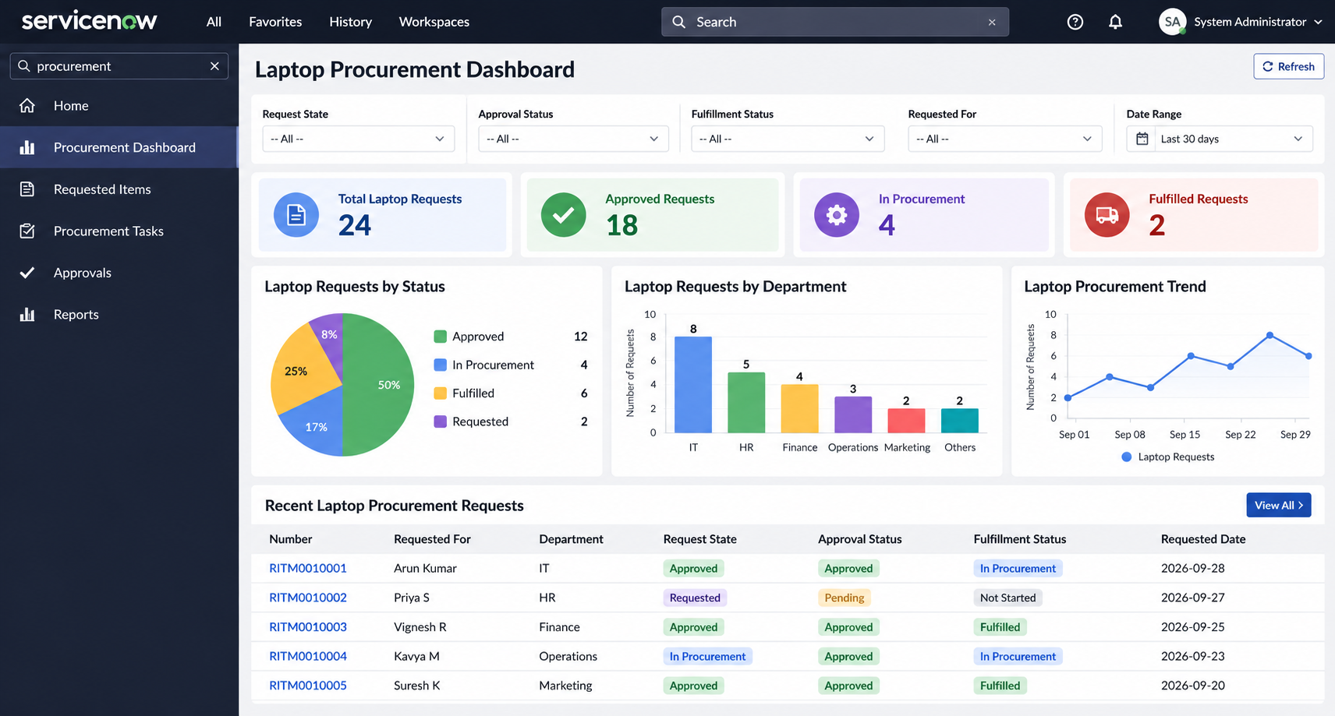  No of Visualizations / Graphs - 3
6 | Story Design | 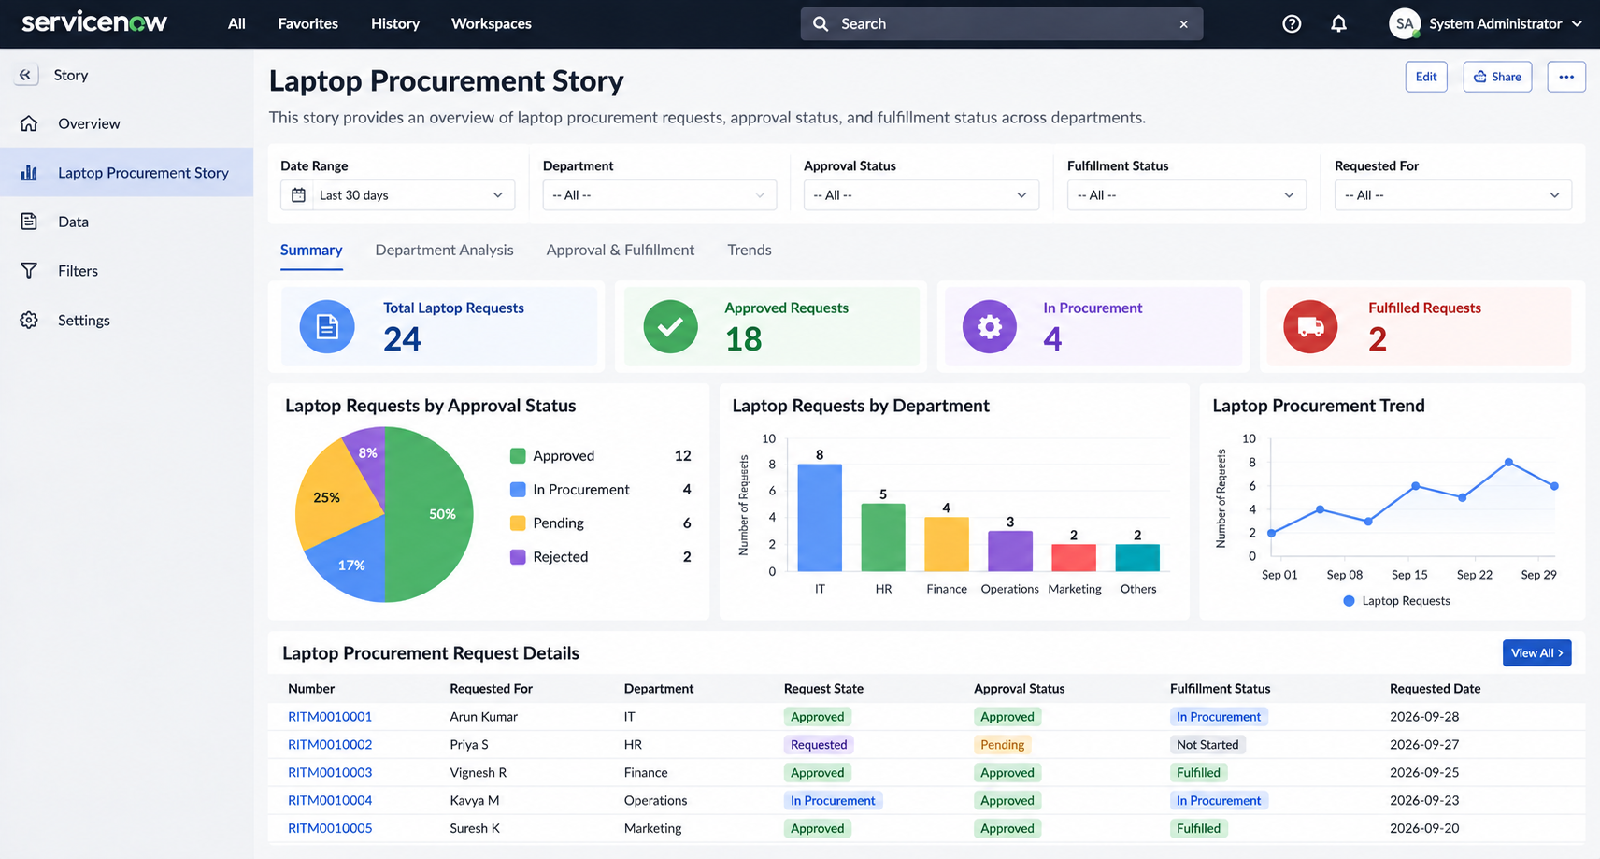  No of Visualizations / Graphs - 3

